Ideation Phase

Define the Problem Statements

Date | 01 October 2026
Team ID | SWTID-2026-2085
Project Name | Import Data using Transform Maps(spreadsheet)
Maximum Marks | 2 Marks

Customer Problem Statement – Import Data Using Transform Maps (Spreadsheet)

Create a problem statement to understand the customer's challenges while importing spreadsheet data into Servicenow. The Customer Problem Statement helps the team identify difficulties such as manual data entry, incorrect field mapping, duplicate records, and data formatting errors

A well-defined problem statement helps the team develop an effective solution using Import Sets and Transform Maps. It enables users to import spreadsheet data accurately, map fields correctly, validate information, reduce manual effort, and minimize errors during the data import process.

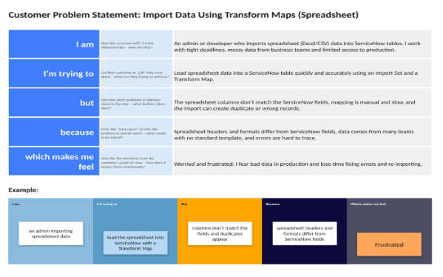

Problem Statement (PS) | I am (Customer) | I’m trying to | But | Because | Which makes me feel
PS-1 | An admin or developer who imports spreadsheet (Excel/CSV) data into ServiceNow tables | Load the spreadsheet data into a ServiceNow table quickly and accurately using a Transform Map | The spreadsheet columns don't match the ServiceNow fields, and mapping them by hand is slow | Spreadsheet headers, date formats and values differ from ServiceNow field names and types | Frustrated and worried about mistakes in the data
PS-2 | An implementation consultant migrating large amounts of spreadsheet data for a client | Update existing records and add new ones in one import without creating duplicates | Re-importing creates duplicate or wrong records, and errors are hard to trace | There is no unique key (Coalesce) set, data comes from many teams with no standard template, and error messages are unclear | Anxious about data quality and about losing the client's trust

